Android recipe Maker

**Software Requirements Specification**

Version 1.1



**Group Id: F1902EA25F**

**Supervisor Name: Muhammad Imran Afzal**

**Revision History**

|  |  |  |  |
| --- | --- | --- | --- |
| **Date (dd/mm/yyyy)** | **Version** | **Description** | **Author** |
| 10/12/2019 | 1.0 | If you are a Cooking Lover but often face situations when you want to make something. Don't be afraid, we have a best recipe maker app which will do that job for you; just start playing around with cooking food at home. | BC160401604  BC160403081 |
| 12/122019 | 1.1 | We have set the alignment of all paragraph and provide the caption and figure number at the end of each figure. | BC160401604  BC160403081 |
|  |  |  |  |
|  |  |  |  |

**Table of Contents**

1. Scope (of the project)
2. Functional Requirements Non Functional requirements
3. Use Case Diagram
4. Usage Scenarios
5. Adopted Methodology
6. Work Plan (Use MS Project to create Schedule/Work Plan)

**SRS Document**

**Scope of Project:**

Android Recipe Maker application is a very useful app for people who love to look and try out new recipes. Android Recipe Maker application provides user flexibility to search, share, save recipe from cloud with an additional capability to maintain personal cookbook for creating new recipe, deleting recipe that are no longer required. It is needed to store all recipes in JSON format on Firebase-real time database.

Android Recipe Maker Application provides capability to user to search top rated, trending recipes. Recipes are displayed with recipe image, title, ingredients list and cooking directions. Category based and ingredients based search is also provided to user

Android Recipe Maker App provide sharing capability, giving user a choice to share recipe through Facebook, Twitter, Google+ and Gmail. This application is a time saver providing recipe in few clicks.

The user is given choice to create personal cookbook, where user can view recipe and delete recipe. The interface is clean and simple. It makes use of Android image button capability to display options on home screen with image icons. The user can search recipes, view added favorite recipe list and access personal cookbook all from home screen.

**Functional and non Functional Requirements:**

**Functional Requirements:**

**Minimum Recipes:** There should be at least 50 recipes; all must be properly categorized like Breakfast, Lunch, Dinner, Beverages, Appetizers, Snacks, and Salads etc.

**Firebase Real-Time Database:** It is needed to store all recipes data in JSON form on Firebase Real-Time Database.

**Registered Users:** Only registered users can view the recipes. So provide registration and as well as login interfaces; store users' credentials on Firebase Real-Time Database in an encrypted form.

**Input Modes:** After successful login, user should be asked to provide ingredients by using following modes:

**Ingredients List:** User can choose food items from available ingredients list; need to make sure that no such item should be there which does not have any corresponding recipe.

**By Typing:** User can provide multiple ingredients by typing via on-screen keyboard.

Voice Input: User can use voice for input; convert audio into text using Voice Recognition technology, provided by Google.

**Latest Recipes:** User can also view recipes without providing any particular ingredients; only 25 latest recipes should be displayed in this case.

**Search Recipes:** According to input, the recipes should be searched from Firebase Real-Time Database and displayed to user. However, user should be properly informed if found no valid recipe.

**Recipe Detail:** Each recipe must have proper Title, valid Description, Ingredients list, Step-by-Step Instructions, Preparation & Cook time, Recipe Servings and Photos etc.

**My Cook Book:** User should be able to save any recipe in the app so that it could be viewed offline; use SQLite or Room database for this purpose. There should be an option to delete recipes in My Cook Book as well.

**Push Notifications:** The user must be informed via Real-Time Push Notifications whenever a new recipe is added on Firebase Real-Time Database.

**Share Recipe:** User should be able to share recipes on Social Media; only My Cook Book's recipes could be shared.

**Backup Feature:** User should be fascinated by giving backup option; all My Cook Book's recipes must be stored/retrieved to/from Firebase Real-Time Database in an encrypted form.

**Non-Functional Requirements:**

**Usability Requirements:**

The application shall be easy to use and intuitive.

The application shall have a user-friendly interface.

GUI shall be simple and clear.

**Performance Requirements:**

The application shall be fast and robust when loading.

The program shall not allow more than 10 min/year of failure.

**Space Requirements:**

The application shall have enough memory space in order to store high number of data.

**Reliability Requirements:**

The application shall not produce an incorrect output.

**Portability Requirements:**

The software shall work in android device.

**Implementation Requirements:**

The application shall be implemented using Android Studio 3.5(latest version)

**Standards Requirements:**

The application shall conform to ISO standards.

**Inter-operability Requirements:**

The application shall allow access to the different department of the application without altering its efficiency and consistency.

**Ethical Requirements:**

The application shall be license free.

**Privacy Requirements:**

Personal information of the registered user shall only be accessed by the administrator.

**Use Case Diagram(s):**

**Unregister**

**User**

**Register**

**User**

**Admin**

(Fig.0.1 Use Case Diagram of Android recipe Maker app)

**Usage Scenarios:**

**Use Case 1:**

|  |  |
| --- | --- |
| **Use Case Title** | Register User |
| **Use Case ID** | ARM1 |
| **Action** | Admin/Users |
| **Description** | User and admin will be able to register him/her through Facebook/Gmail account or using our app sign up functionality to view the recipes. |
| **Alternative Paths** | If some information is incorrect in records so user can update record for that do all steps again |
| **Pre-Conditions** | The use case begins when the actor type his/her name password on the sign up form |
| **Post conditions** | The user entered successful information and is returned to the home page as a Logged In User |
| **Author** | Saood Ul Hansian, Zaid Ahmad. |
| **Exceptions** | Server not respond or data format is not according to Db format. |

* **Use Case 2:**

|  |  |
| --- | --- |
| **Use Case Title** | Login |
| **Use Case ID** | ARM2 |
| **Action** | Admin/User |
| **Description** | User will be able to login him/ herself. |
| **Alternative Paths** | If input is invalid, so user will provide it again. |
| **Pre-Conditions** | User register himself and input data correctly according to format in DB. |
| **Post conditions** | User should be able to see/search the recipes.. |
| **Author** | Saood Ul Hansian, Zaid Ahmad. |
| **Exceptions** | Login information incorrect or server not respond. |

**Use Case 3:**

|  |  |
| --- | --- |
| **Use Case Title** | Logout |
| **Use Case ID** | ARM3 |
| **Action** | Admin/Users |
| **Description** | Users and admin logout form our app. |
| **Alternative Paths** | No alternate step. |
| **Pre-Conditions** | Logout options should be available on side drawer. |
| **Post conditions** | User should be logout from the app. |
| **Author** | Saood Ul Hansian, Zaid Ahmad. |
| **Exceptions** | Server not respond if the internet connection is down. |

**Use Case 4:**

|  |  |
| --- | --- |
| **Use Case Title** | View Top Recipes |
| **Use Case ID** | ARM4 |
| **Action** | Admin/Users |
| **Description** | Users/Admin can see top 25 recipes of our App |
| **Alternative Paths** | No alternate step. |
| **Pre-Conditions** | User should be login and on home Screen. |
| **Post conditions** | On select recipe user will be able to view the ingredients, share on social media, directions and mark favourite. |
| **Author** | Saood Ul Hansian, Zaid Ahmad. |
| **Exceptions** | Server not respond if the internet connection is down. |

**Use Case 5:**

|  |  |
| --- | --- |
| **Use Case Title** | Input Voice Method |
| **Use Case ID** | ARM5 |
| **Actors** | Admin/Users |
| **Description** | User can provide multiple ingredients by typing via on-screen keyboard and user can use voice for input and application will convert audio into text using Voice Recognition technology, provided by Google. |
| **Alternative Paths** | At the right corner of search bar there will be input for voice icon |
| **Pre-Conditions** | By typing |
| **Post conditions** | Application will convert audio into text using Voice Recognition technology, provided by Google and produces result if condition meets. |
| **Author** | Saood Ul Hansian, Zaid Ahmad. |
| **Exceptions** | Server not respond if the internet connection is down. |

**Use Case 6:**

|  |  |
| --- | --- |
| **Use Case Title** | Manage Users |
| **Use Case ID** | ARM5 |
| **Action** | Admin |
| **Description** | Admin will be able to create new recipes ,delete recipes ,edit recipes |
| **Alternative Paths** | No |
| **Pre-Conditions** | On selecting recipe item there should be edit ,delete option and on Side drawer should be add new recipe option. |
| **Post conditions** | Upon editing ,deleting and create new recipe our db should be updated. |
| **Author** | Saood Ul Hansian, Zaid Ahmad. |
| **Exceptions** | Server not respond if the internet connection is down. |

**Use Case 7:**

|  |  |
| --- | --- |
| **Use Case Title** | My Cook Book |
| **Use Case ID** | ARM5 |
| **Action** | Admin/User |
| **Description** | The user is given choice to create personal cookbook, where user can view recipe and delete recipe |
| **Alternative Paths** | No |
| **Pre-Conditions** | There should be heart like item on the below right corner of item. |
| **Post conditions** | Upon tapping heart icon that recipe item should be added to favorites. |
| **Author** | Saood Ul Hansian, Zaid Ahmad. |
| **Exceptions** | Server not respond if the internet connection is down. |

**Use Case 8:**

|  |  |
| --- | --- |
| **Use Case Title** | Share on social media |
| **Use Case ID** | ARM5 |
| **Action** | Admin/User |
| **Description** | Upon selecting recipe item at top right corner there should be share recipe icon |
| **Alternative Paths** | No |
| **Pre-Conditions** | There should be heart like item on the below right corner of item. |
| **Post conditions** | Upon tap on share there will be popup bottom bar option share on Facebook ,Gmail etc and after selecting sharing media application will create link message. |
| **Author** | Saood Ul Hansian, Zaid Ahmad. |
| **Exceptions** | Server not respond if the internet connection is down. |

**Adopted Methodology**

**VU Process Model:**

The methodology that we have adopted for this Project is VU Process Model which is a combination of two very well-known and easy to use models i.e. Spiral Model and Waterfall Model. The idea of this model is that to get the benefits of both these models. Essentially, Waterfall Model is a framework for software development in which development proceeds sequentially through a series of phases, starting with system requirements analysis and leading up to product release and maintenance, whereas the main key features of spiral model is risk management at regular stages in the entire software development cycle. The two models are explained below:

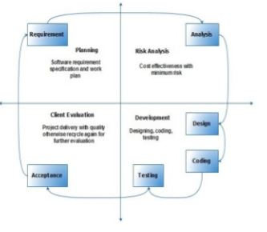

(Fig.0.2 Process of Making app)

**Waterfall Model:**

As the Waterfall Model was first Process Model to be introduced, it is very simple to use and understand. In this model the whole process of software development is divided into separate phases and all these phases are executed in a sequential manner i.e. each phase must be completed for next phase to begin. In waterfall model the progress of software development be flowing steadily downwards through the phases. These phases are described here in below:

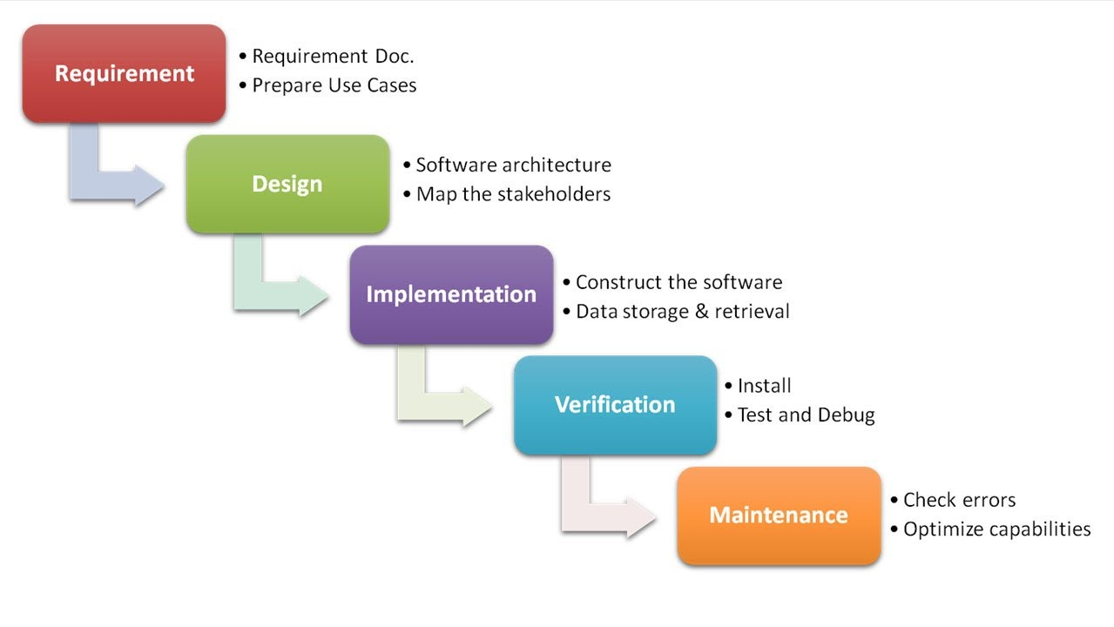

(Fig.0.3 Waterfall Model)

* Requirements: In the first phase system specification is developed by collecting and studying the functional and non-functional requirements, functions and purposes of the final product.
* System and Software Design: The gathered requirement specifications from the previous phase are studied here and system design is prepared in this phase. System design helps in specifying hardware and software systems and it establishes overall system architecture.
* Implementation and Unit Testing: In this phase the system is first developed in small programs called units with inputs from system design from the previous phase. Each unit is developed and tested for its functionality which is referred to as Unit Testing.
* Integration and System Testing: All the units developed in the Implementation Phase are integrated into a system after testing of each unit. The designed software is put to constant software testing to find if there is any error and ensure that client does not face any problem during installation of the software.
* Operation and Maintenance: Finally, the system is installed and put into practical use. Maintenance involves correcting errors which were not discovered in the earlier stages or improving performance. Modifications are also made as and if new requirements are discovered.

**Spiral Model:**

This model overcomes the cons of waterfall model by adding a very high emphasis on risk analysis to its phase. Spiral Model contains 4 phases i.e. Planning, Risk Analysis, Engineering and Evaluation and these phases are iteratively followed by one after another in order to avoid maximum risk during software development. In other words, given task move through these four phases till the entire software is build.

**Planning:** Requirements are studied and gathered in this phase. It includes estimating the cost, schedule and resources for the spirals.

**Risk Analysis:** Risk Analysis includes identifying, estimating, and monitoring technical feasibility and management risks, such as schedule slippage and cost overrun. Once the risks are identified, risk mitigation strategy is planned and finalized.

**Engineering:** Actual development and testing of the software takes place in this phase. It includes testing, coding and deploying software at the customer site.

**Evaluation:** After testing the build, at the first phase, the customer evaluates the product and provides feedback.

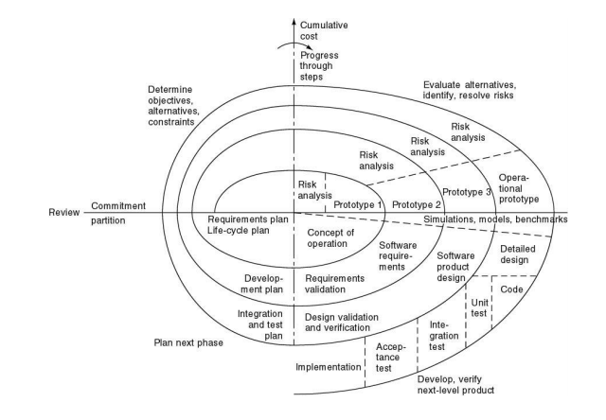

(Fig.0.3 Spiral Model)

**Work Plan (Use MS Project to create Schedule/Work Plan**

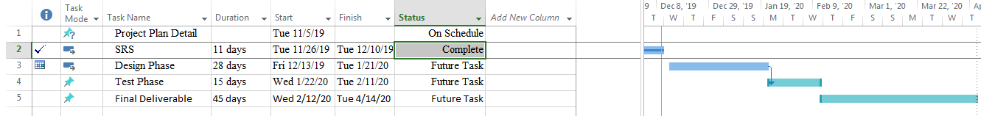

(Fig.0.3 Workplan)